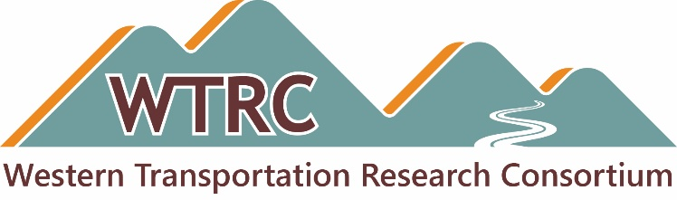

TAC Meeting — February 11, 2026
Agenda
Updated February 6, 2026

Date: Wednesday, February 11, 2026
Time: 12:00 p.m. Mountain
Duration: 90 minutes
Teams Meeting ID: 241 282 263 510 78 and Passcode: PD66r4FU or use direct link, Join the meeting
Audio: Use your computer mic and headphones, or dial 469-998-7594 and enter 697 591 134#

Attachments
- WTRC Research Idea - 2026 Submission Form.docx

Links
- WTRC Research:
Public website: https://westerntrc.org/research
Members-only updates table:
https://westerntrc.org/2025-research-project-and-activities
Password: WTRC2024!
- WTRC Microsoft OneDrive folder:
https://westerntrc.org/member-files
Password: WTRC2024!

Welcome and Opening Business
- Call to Order — TAC Chair Cameron Kergaye, Utah DOT
- Updates:
  - Membership and state representatives — Brian Hirt, CTC & Associates
  - Commitments and transfers — David Stevens, Utah DOT
  - CTC & Associates contract — Brian

WTRC 2025 Research Efforts
- Review status and next steps for each project
- Comments, questions or concerns

May 19-21, 2026 Meeting and Peer Exchange – Boise, ID
- Host states: Idaho, New Mexico, Washington
- Travel Memo
- Format, Topics and Guest(s)
- Anything for Amanda to share

WTRC 2026 Research
- Timeline and process for submissions
  - In progress — any questions?
  - Communication / Listserv
- Timeline and process for initial ranking
- Final selection in Boise

Communication Products
- Website
- Updates and news posts

Other Business
- Open discussion

Closing Business
- Next meetings
  - Boise in May 2026
  - Pittsburgh at AASHTO RAC in July 2026
  - Interested 2027 Peer Exchange co-hosts and site hosts
- Review action items

Adjourn
- Cameron Kergaye

