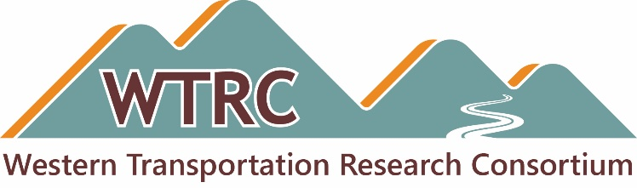

Western Transportation Research Consortium
Minutes

Web Meeting
Monday, February 24, 2025
10:00am –11:00 a.m. MT

Attendees:

- Alaska: Cristina DeMattio
- California: Joe Horton, Sang Le, Dara Wheeler
- Colorado: Steve Cohn
- Idaho: Amanda Laib
- Montana: Rebecca Ridenour
- Nebraska: Mark Fischer, Lieska Halsey
- Nevada: Lucy Koury
- North Dakota: T.J. Murphy
- Oklahoma: Gary Hook
- Texas: Kevin Pete
- Utah: Cameron Kergaye, David Stevens
- Washington: Jon Peterson
- Wyoming: Enid White
- CTC & Associates: Brian Hirt, Kirsten Seeber

Member states not in attendance: New Mexico

Agenda
Welcome and Opening Business
- Call to Order — TAC Chair Cameron Kergaye, Utah DOT
- Approve the November 2024 WTRC meeting minutes

  - The opportunity to review the minutes is sufficient for approval. Going forward, Brian will send draft minutes, make member’s comments and post them on the WTRC website.
- November 2024 WTRC Peer Exchange final report
  - The final report is posted on the WTRC website.
  - The host states provided their approval on the final report during the meeting.
  - CTC will send the report to RAC for inclusion in their peer exchange reports database. Report submitted and posted to https://transportation.org/research/resources/peer-exchange-reports/
- Commitments and transfers update (as of 2/11/25 FHWA Transfers spreadsheet)
  - States that have transferred FFY25 funds are Alaska, California, Idaho, Montana, Nevada, New Mexico, North Dakota, Oklahoma, Texas, Utah, Washington and Wyoming.
  - FFY25 transfers are still needed from Colorado and Nebraska.
  - States should send their FFY2025 transfers to help fund the May meeting and upcoming research projects.
May 20-22, 2025 Meeting and Peer Exchange – Austin, TX
- The May 2025 meeting will be 2.5 days. Those who can’t travel home on Thursday, May 22 may stay until Friday, May 23.
- Draft agenda
  - Peer exchange themes
    - Day 1
      - Measuring Research Success
      - Pooled Fund Management
    - Day 2 – Regional Research. There will be at least one presentation on this topic.
    - The host states will present on both themes. Remaining states will present on one theme or the other. Presentation guidance will go out to all states in advance of the meeting.
  - What comes out of day one may feed into into what is discussed during the rest of the meeting.
  - The WTRC business meeting will comprise days two and three.
- Invited guests
  - Michael Buffalino, Oregon DOT – Doesn’t know yet whether he can attend.
  - Thad Bauer, South Dakota DOT – South Dakota has joined the pooled fund, so Thad would no longer be considered a guest at this point.
  - Khyle Clute, Iowa DOT
    - Brian will extend an invitation to Khyle on WTRC’s behalf
WTRC Research Idea —2025 Submission Form
- Research Ideas Submission Process
  - Use the submission form as it is right now and identify issues with the form as members complete it.
    - Brian will send the members the latest form with instructions. Item completed.
  - Each member will submit at least one, but no more than three, projects.
  - Members should consider the level of work needed to address the topic such as light synthesis work or something more involved.
  - Regional issues will score higher. Propose statements that are of interest to many of the states.
  - Selection process
    - Brian will send the members all idea submissions for their internal review and scoring.
    - Members will send their scores (rating scale TBD) to Brian prior to the Austin meeting. Brian will define what the scores mean when he sends the form to members.
    - Brian will compile the scores, put the projects in rank order and send the information to the members.
    - The members will discuss the top projects during the meeting.
    - The goal is to come away from the meeting with the topics selected and a plan to move forward with a slate of research efforts, including completing the scoping and contracting efforts needed.
  - Dates
    - Members will have from February 4 to March 27 to submit their completed forms to Brian.
    - Members will have from April 7 to May 7 to vote on the submitted ideas.
  - Utah and CTC will determine how much money is available for research projects.
SME Surveys
- To begin building regional connections between the SME groups, members will determine the important subject matter areas for the states to convene their SMEs for discussion. This will be discussed further in Austin.
Adjourn — Cameron Kergaye

