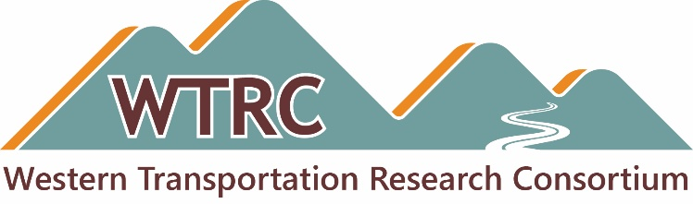

TAC Meeting Agenda

Date: Monday, February 24, 2025
Time: 10:00 a.m. Mountain
Duration: 60 minutes
Teams Meeting ID: 286 622 362 020 and Passcode: sJ2BK97N or use direct link, Join the meeting
Audio: Use your computer mic and headphones, or dial 872-242-8805 and enter 318 425 507#

Attachment:
- May 20-22, 2025 WTRC Meeting and Peer Exchange Draft Agenda
- WTRC Research Idea —2025 Submission Form
Welcome and Opening Business
- Call to Order — TAC Chair Cameron Kergaye, Utah DOT
- Approve the November 2024 WTRC meeting minutes
- Remind members to send their comments on the November 2024 WTRC Peer Exchange final report
- Commitments and transfers update
May 20-25, 2025 Meeting and Peer Exchange – Austin, TX
- Review draft agenda
- Invited guests
  - Michael Buffalino, Oregon DOT
  - Thad Bauer, South Dakota DOT
  - Khyle Clute, Iowa DOT – Alternate guest
WTRC Research Idea —2025 Submission Form
- Address TAC comments on submission form
- Research Ideas Submission Process
  - What DOTs are doing internally to complete the form? Work with SMEs, complete it themselves, other?
  - What will CTC do with the collected information after the forms are submitted? What will CTC send to the group before the meeting? Will ideas be scored or ranked prior to the May meeting?
  - What will happen at the May meeting? How will the projects be framed? How will the member talk about them? Selection process?
  - Key dates and lead times
    - Submitted problem statements will be provided to the Advisory Committee 30 days in advance of voting.
    - Other
SME Surveys
- CTC update on draft survey
- Next steps
Adjourn — Cameron Kergaye

