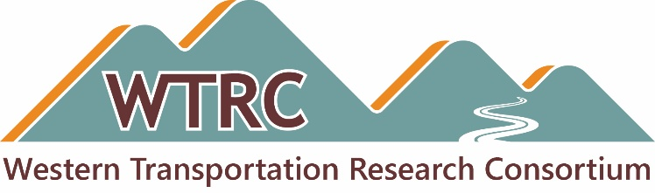

TAC Meeting Agenda

Date: Monday, October 20, 2025
Time: 11:30 a.m. Mountain
Duration: 90 minutes
Teams Meeting ID: 271 046 445 127 1 and Passcode: uP9D2Wb6 or use direct link, Join the meeting
Audio: Use your computer mic and headphones, or dial 872-242-8805 and enter 954 695 546#

Attachments
- WTRC Meeting - 2025-May - DRAFT Notes for WTRC Review.docx
- WTRC Research Idea - 2026 Submission Form - DRAFT for TAC Review.docx

Link
- WTRC Microsoft OneDrive folder with a common member password:
https://westerntrc.org/member-files
WTRC2024!

Welcome and Opening Business
- Call to Order — TAC Chair Cameron Kergaye, Utah DOT
- Approve the May 2025 WTRC meeting minutes — Cameron
  - Motion, second and approval
- Members and state representatives — Brian Hirt, CTC & Associates
- Commitments and transfers — David Stevens, Utah DOT
- CTC & Associates contract — Brian

WTRC 2025 Research
- WTRC 2025 Research Activities table
  - Review status and next steps for each project
  - Comments, questions or concerns
    - Key Question: Moving forward with BABA project?

May 18-21, 2026 Meeting and Peer Exchange – Boise, ID
- Host states: Idaho, New Mexico, Washington
- Initial planning
- Format, Topics and Guest(s) TBD

WTRC 2026 Research
- Revised Research Idea Submission form for 2026
- Timeline and process for submission, review and voting

Communication Products
- Bimonthly email updates and news posts — WTRC “look in” and update
- Research results
- Website

Other Business
- Open discussion

Closing Business
- Review action items
- Next meeting

Adjourn
- Cameron Kergaye

